# Home

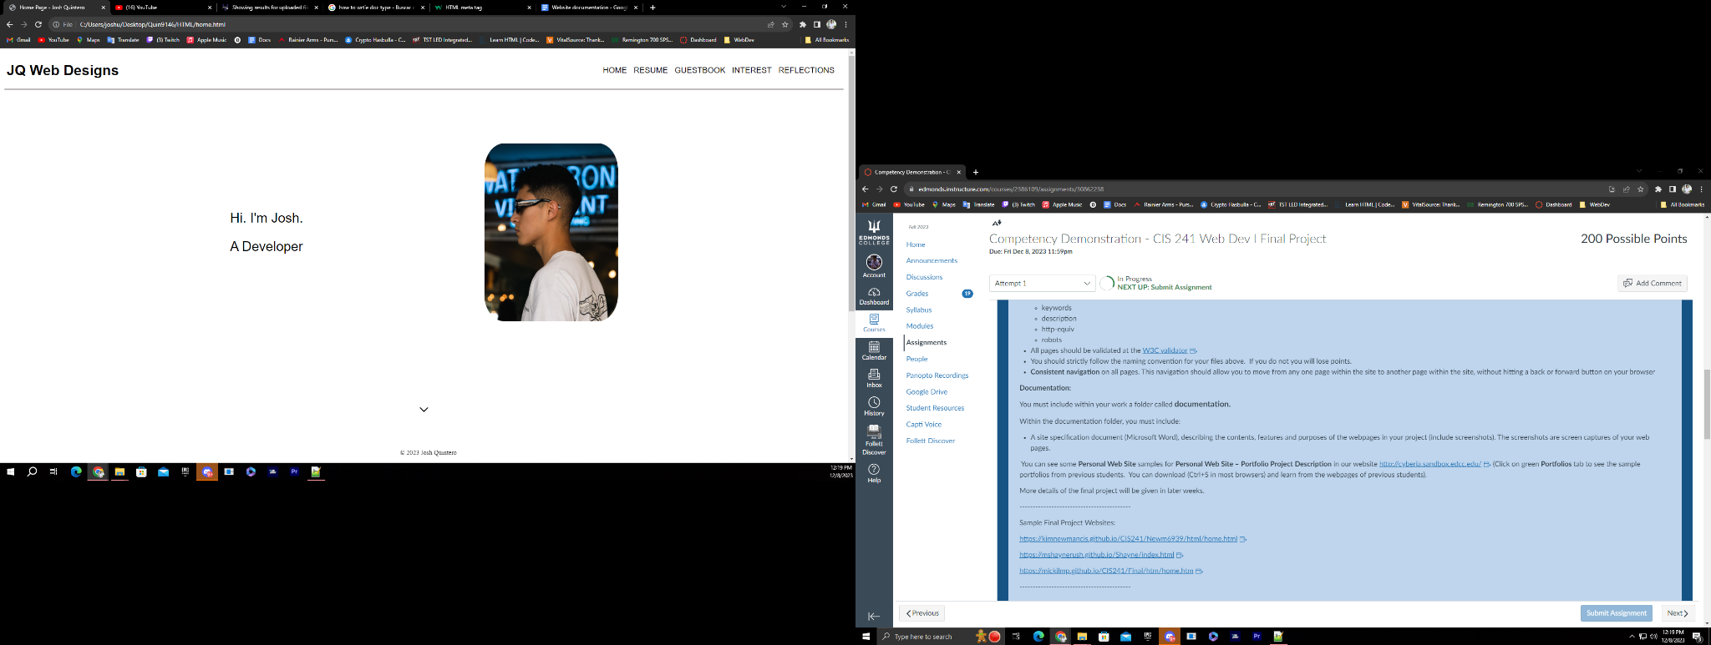

This is what you see when the page loads up, I added a navigation bar at the top, and a drop-down arrow that takes you to the “about me” section when clicked. 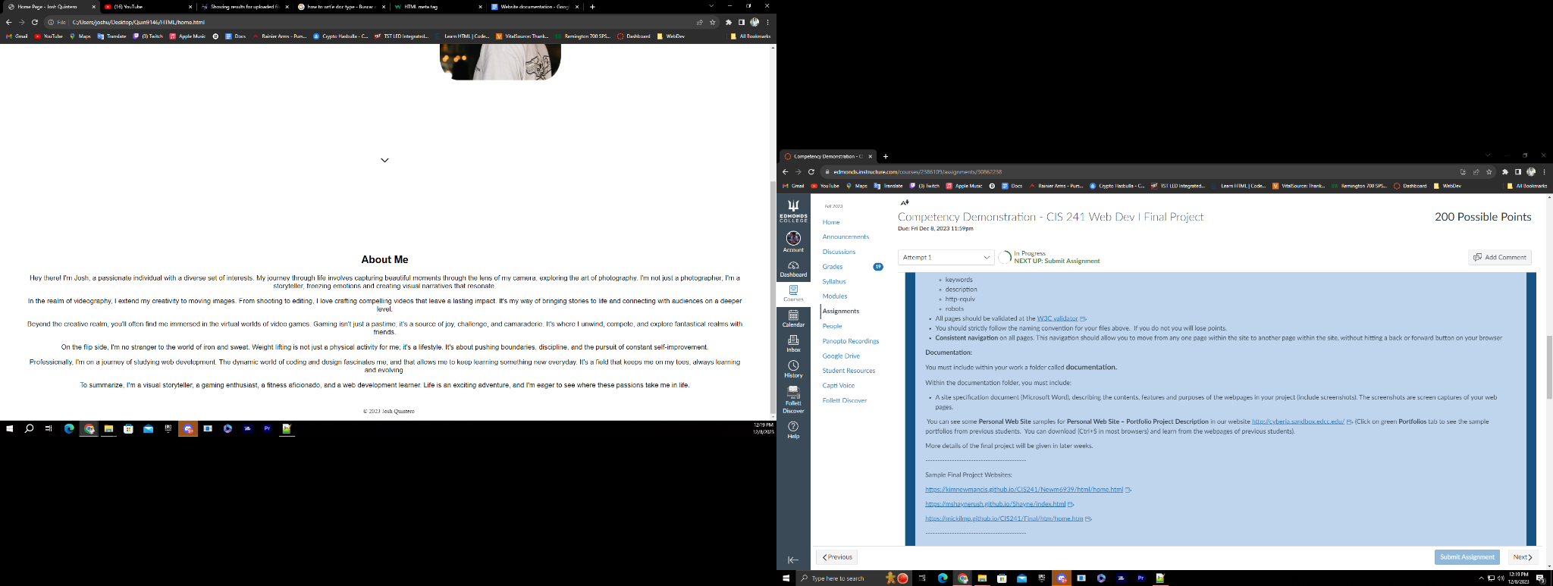

# Resume

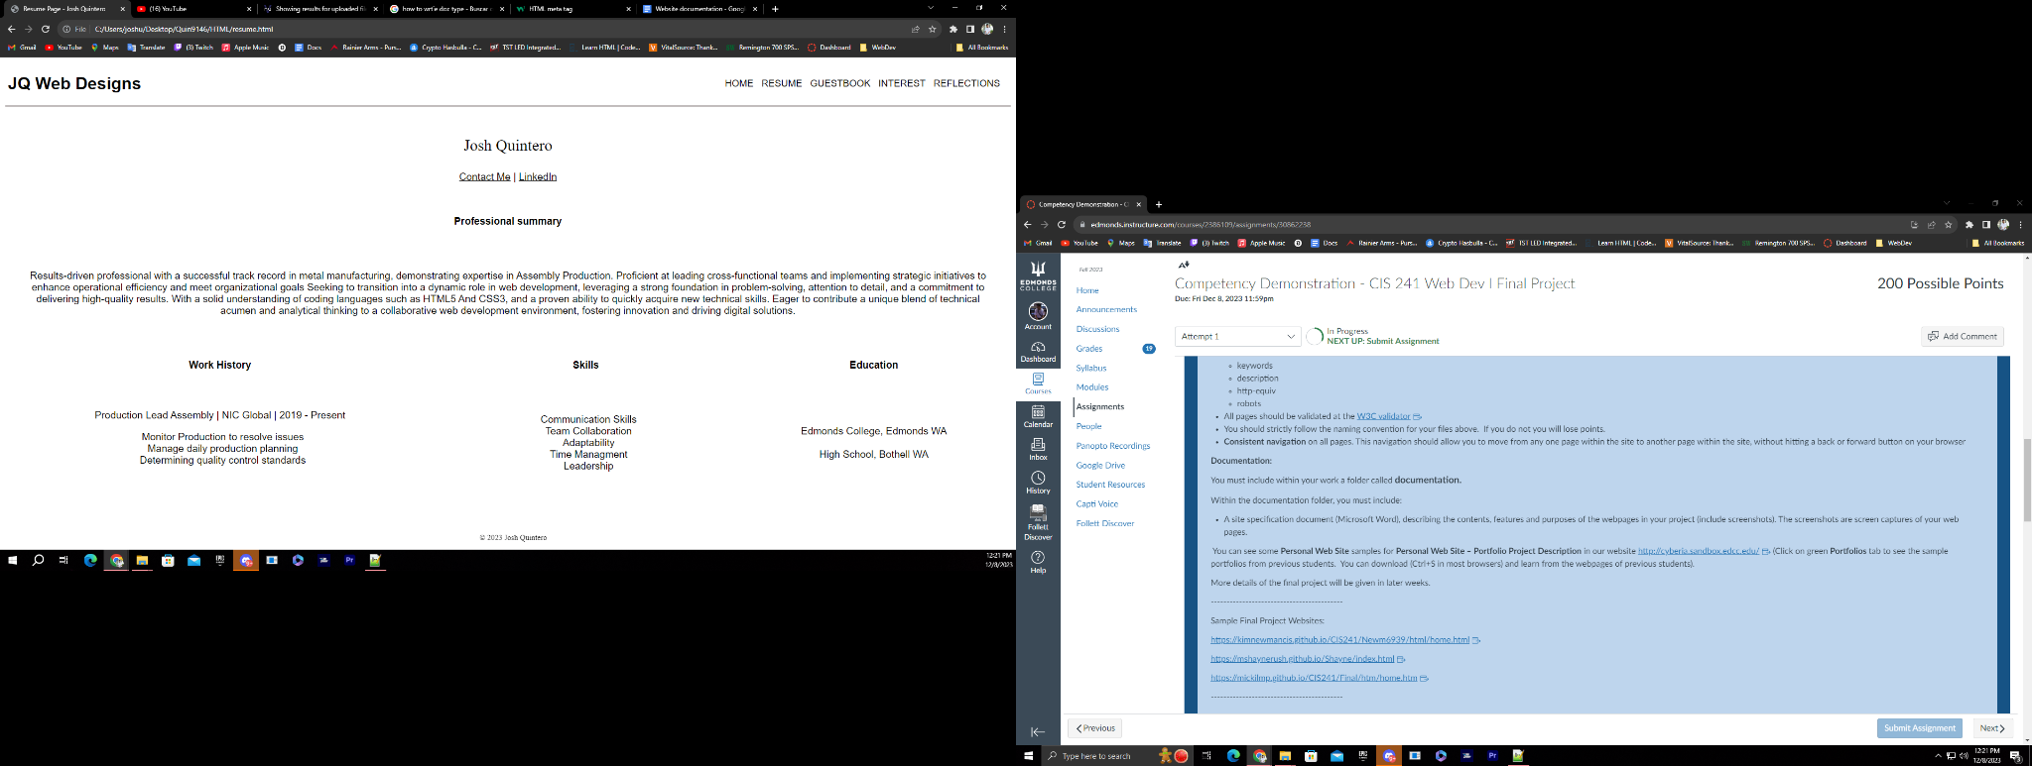

Here I laid out my resume using the table method, i also added the top navigation bar to keep the same theme going.

# Guestbook

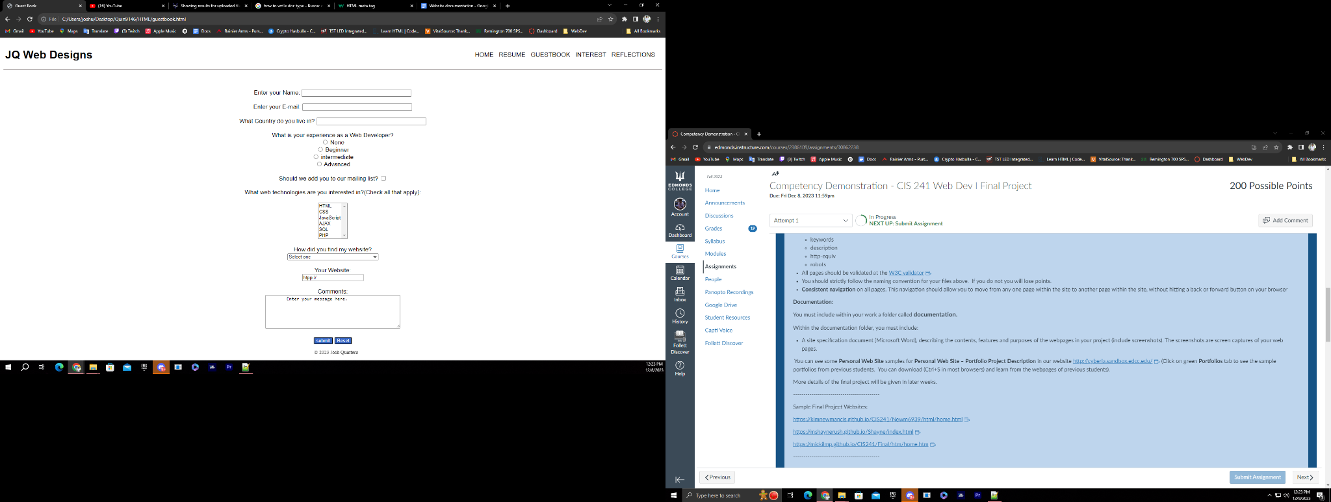

This is the guestbook section, I added various types of inputs and stylized submit and reset buttons. And the navigation bar to keep the same theme.

# Interest

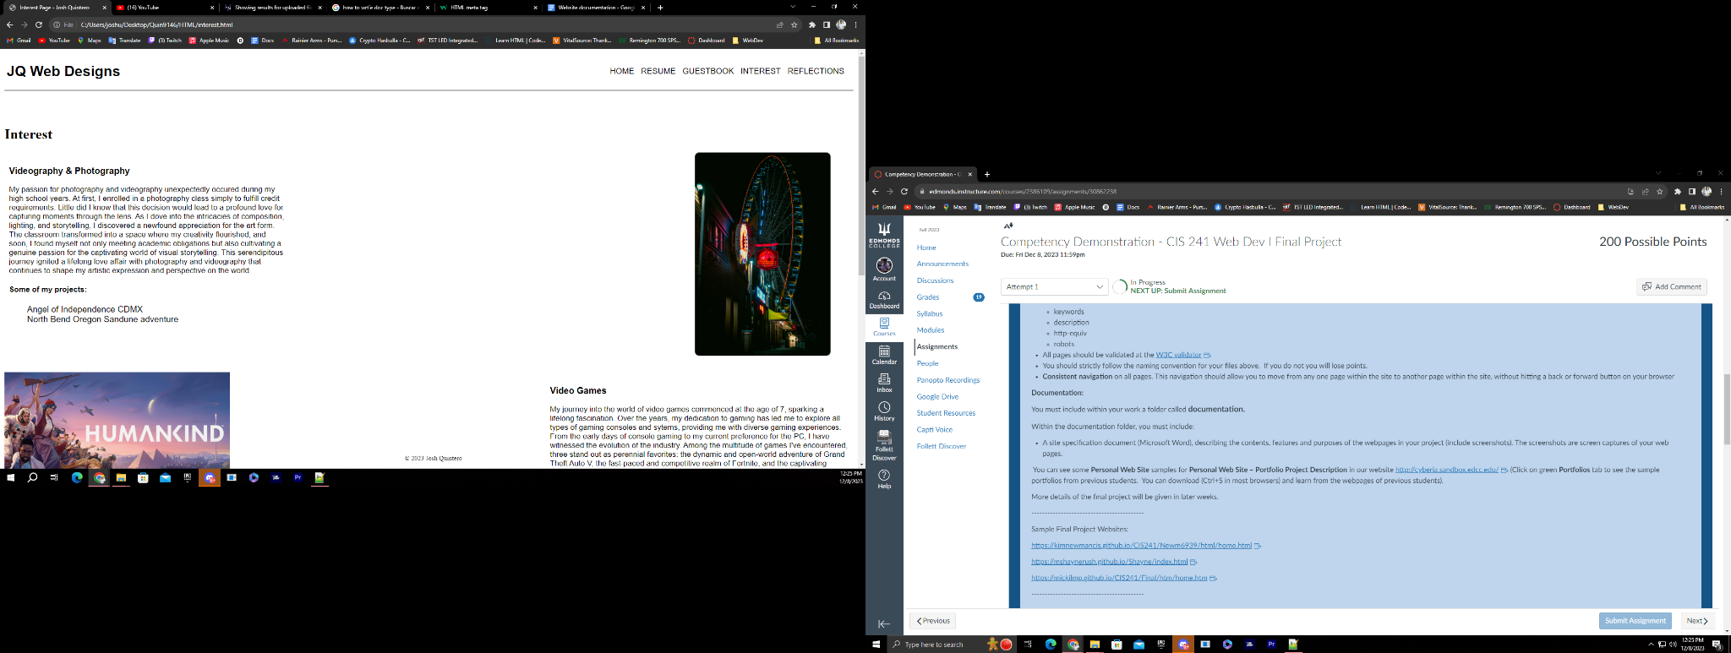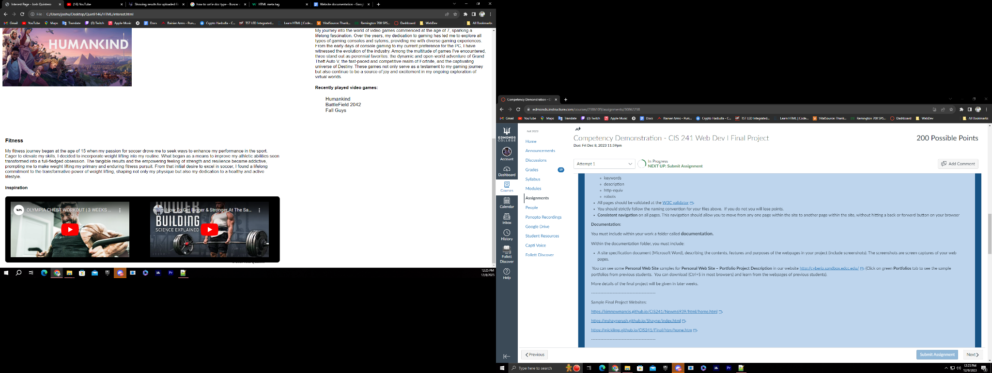

For the interest page, I added multiple images and embedded YouTube videos, I also added two lists that link outside and open on a separate tab. I also attempted a different layout on this page and the navigation bar.

# Reflections

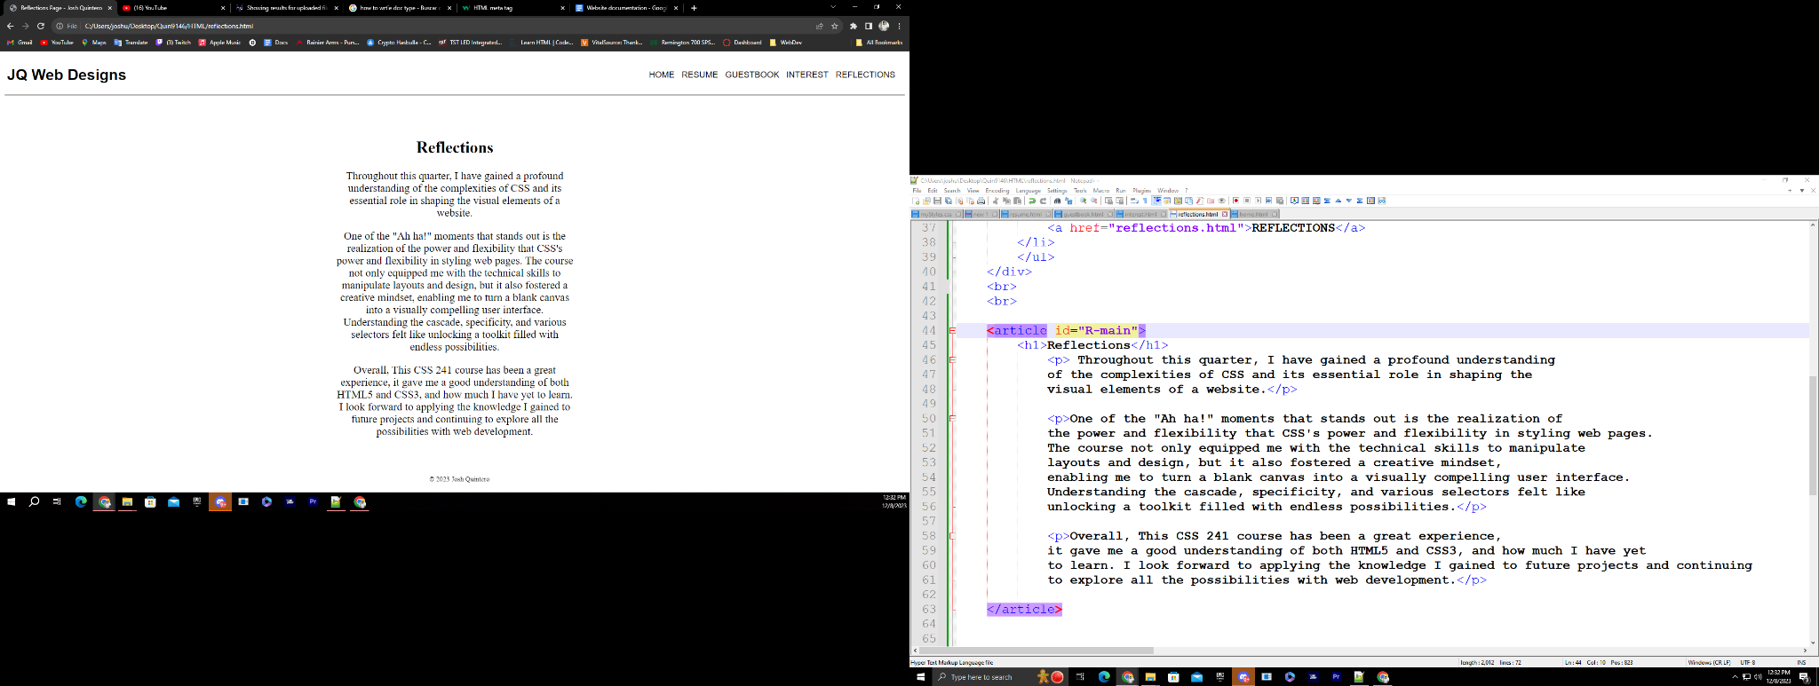

For the reflections page I kept it simple, I used the article tag to contain the information and then centered it and stylized it, also added the navigation bar.